Phase-Transition-Driven Design of IGZO Optoelectronic Devices: From Amorphous Synapses to Crystalline Photosensors

Min Ju Jo¹, Sangwoo Choi², Jisoo Jung¹, Hyeoksoon Hwang¹, Uhyeok Song¹, You Jin Noh¹, Do-Kyung Kim^{1,*}, Jin-Hyuk Bae^{2,*}
¹ Department of Advanced AI Engineering, Kangwon National University
² School of Electronics Engineering, Kyungpook National University

This study investigated the post-annealing effects (300 – 700 ℃) on IGZO optoelectronic thin-film transistors. To rule out the interference of initial electrostatic effective bias induced by variations in the turn-on voltage (V_{ON}), the applied gate voltage (V_{G}) was normalized to V_{ON} – 1 V during a 1 s, 455 nm optical pulse evaluation. As the annealing temperature increased from 300 ℃ to 500 ℃, V_{ON} shifted negatively, and the photocurrent decay time (τ) significantly increased. (Fig. 1) This indicates that the thermodynamic structure evolves to strongly stabilize the ionized oxygen vacancy (V_{O}) state up to 500 ℃. Furthermore, this structural evolution maximizes the activation energy barrier required for these ionized states to structurally relax back into the neutral V_{O} state. [1] Conversely, above 600 ℃, V_{ON} recovers toward the positive direction, accompanied by a decrease in τ. In particular, at 700 ℃, thermal energy might induce nano-crystallization, which degrades the subthreshold swing (SS) due to the formation of grain boundary traps. (Fig. 1) [2] Additionally, the resulting lattice rigidity restricts structural relaxation, leading to a drastic decrease in both the photocurrent (I_{peak} - I_{dark}) and τ. In conclusion, this study elucidates the thermodynamic state transitions and lattice relaxation mechanisms of V_{O} defects. Furthermore, this research suggests that the amorphous phase, which facilitates lattice relaxation, is optimally suited for neuromorphic devices. In contrast, the crystalline phase, characterized by lattice rigidity, can be applied to photosensors.

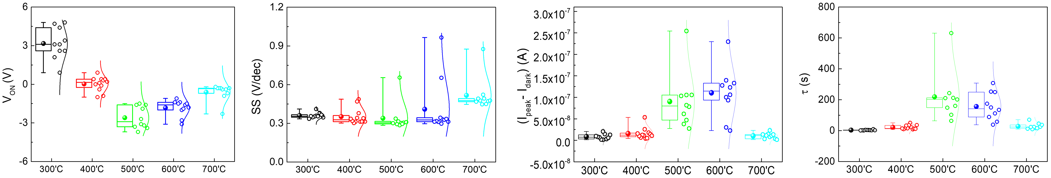
Fig 1. Characteristics of V_{ON}, SS, (I_{peak}–I_{dark}), and τ as a function of post-annealing temperature

Acknowledgments This research was supported by the Glocal 30 program of Kyungpook National University, funded by the Ministry of Education(MOE).
References [1] Gao, Shi-Long, et al. ACS Applied Electronic Materials 6.3, 1542-1561 (2024). [2] Ahn, Byung Du, et al. Japanese journal of applied physics 51.1R, 015601 (2012).

